**YOLO V8 Model Architecture**

Understanding the architecture of YOLO (You Only Look Once) V8 involves exploring its three essential blocks: Backbone, Neck, and Head. These blocks form the core of the algorithm and are responsible for the various stages of object detection. Below, we delve into the function and activities of each block.



## Backbone

### **Function:**

The Backbone, also known as the feature extractor, is responsible for extracting meaningful features from the input image.

### **Activities:**

* **Captures simple patterns:** In the initial layers, the Backbone captures basic patterns such as edges and textures.
* **Multi-scale representation:** As the network goes deeper, it captures features at different levels of abstraction, from simple textures to complex shapes.
* **Hierarchical representation:** The Backbone provides a rich, hierarchical representation of the input, essential for accurate object detection.

The Backbone typically includes several convolutional layers that perform these tasks. Earlier versions of YOLO used the Darknet-53 architecture, while newer versions like YOLOv5 and YOLOv8 have evolved to include more efficient and powerful architectures.

## Neck

### Function:

The Neck acts as a bridge between the Backbone and the Head, performing feature fusion operations and integrating contextual information.

### Activities:

* **Feature fusion:** The Neck assembles feature pyramids by aggregating feature maps obtained from different stages of the Backbone. This ensures that the network can detect objects of various sizes.
* **Context integration:** By integrating contextual information, the Neck improves detection accuracy, considering the broader context of the scene.
* **Dimensionality reduction:** The Neck reduces the spatial resolution and dimensionality of the features to facilitate computation. This increases speed but can sometimes reduce the quality of the model.

The Neck often uses techniques such as FPN (Feature Pyramid Network) or PANet (Path Aggregation Network) to achieve these tasks. In YOLOv8, advanced modules like C2 and C2f are used for optimized performance.

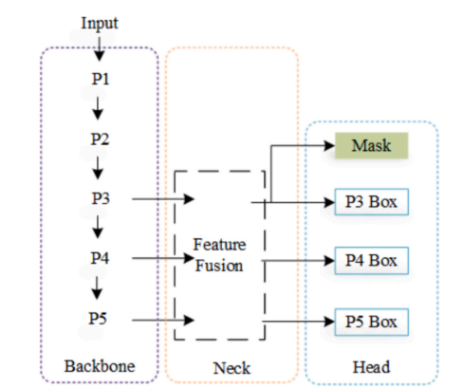

## Head

### Function:

The Head is the final part of the network responsible for generating the network’s outputs, such as bounding boxes and confidence scores for object detection.

### Activities:

* **Bounding box generation:** The Head generates bounding boxes associated with potential objects in the image.
* **Confidence scoring:** Each bounding box is assigned a confidence score indicating the likelihood of an object being present.
* **Object classification:** The detected objects in the bounding boxes are classified into categories.

The Head typically includes convolutional layers and fully connected layers that process the features and make final predictions.

**Previous Versions Using the C3 Module**

The C3 Module, employed in earlier iterations of YOLO such as YOLOv5, was a fundamental component of the model architecture. It featured a structure comprising three convolutional layers and utilized the Cross-Stage Partial (CSP) technique. This technique involved splitting the input into two parts, processing one with convolutions, and then merging them. While effective in extracting detailed features, the C3 Module was noted for its higher complexity and computational intensity.

**YOLOv8 Using C2 and C2f Modules**

In the evolution of YOLO, particularly in YOLOv8, there was a transition towards utilizing the C2 and C2f modules. The C2 Module, characterized by its two convolutional layers, adopted a similar splitting and merging process as the C3 Module but with fewer convolutions. This architectural change resulted in a simpler and less computationally intensive model while maintaining good performance, thereby optimizing efficiency in YOLOv8. Additionally, YOLOv8 introduced the C2f Module as an optimized version of the C2 Module, designed to process images more quickly while preserving accuracy.

**Key Differences**

When comparing the C3, C2, and C2f modules, several key differences emerge. Firstly, in terms of convolutions, the C3 Module utilized three convolutions, whereas the C2 Module reduced this to two convolutions. Consequently, the C3 Module exhibited higher complexity and power, while the C2 Module prioritized simplicity and efficiency. Furthermore, the C2f Module distinguished itself as an optimized, faster variant of the C2 Module, maintaining similar performance while processing images more rapidly. This emphasis on speed underscores the importance of real-time processing capabilities in applications where timely detection is critical.

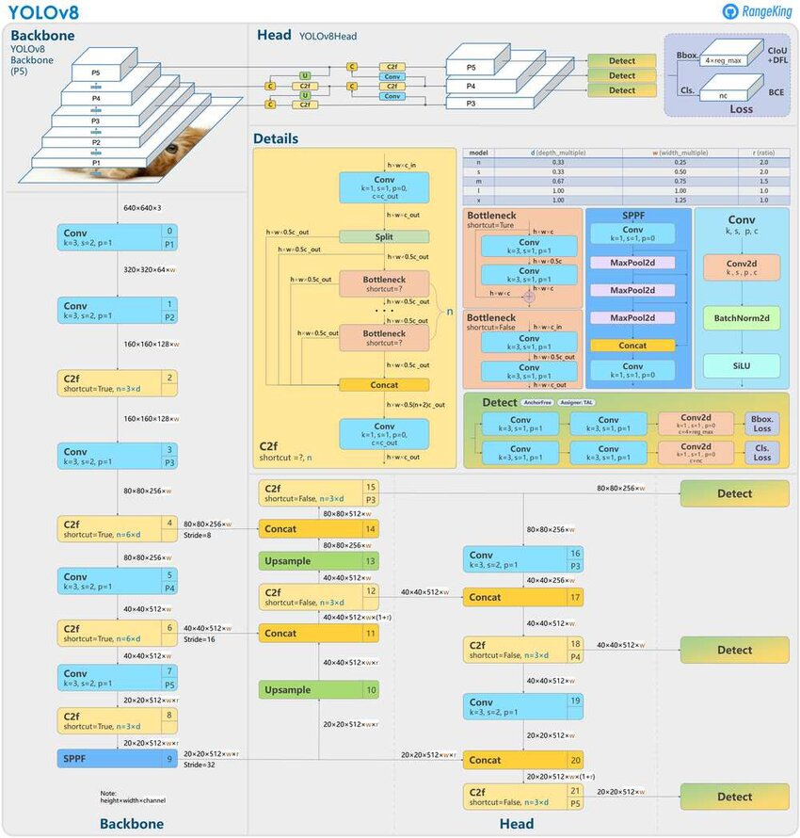

Block diagram of YoloV8

**Convolution (Conv) in YOLOv8**

The YOLO architecture adopts a local feature analysis approach, focusing on extracting features from images in a localized manner rather than analyzing the entire image at once. This strategy is crucial for reducing computational effort and enabling real-time detection. Convolutions play a central role in this process, serving to extract meaningful features from the input data.

**Convolution:**

Convolution is a fundamental mathematical operation that combines two functions to produce a third function. In the context of computer vision and signal processing, convolution is commonly employed to apply filters to images or signals, thereby highlighting specific patterns or features. Within convolutional neural networks (CNNs), convolution is utilized to extract features from input data such as images. Convolutions are characterized by parameters such as Kernels (K), Strides (s), and Paddings (p).

**Kernel:**

The kernel, also referred to as the filter, is a small matrix of numerical values that is convolved with the input (image or signal) during the convolution operation. The primary objective of the kernel is to apply local operations to the input data, thereby detecting specific characteristics or features. Each element within the kernel represents a weight that is multiplied by the corresponding value in the input during convolution.

**Stride:**

Stride dictates how the convolutional kernel traverses the input image. A stride of 1 implies that the kernel shifts one pixel at a time, while a stride of 2 causes it to skip every other pixel. The choice of stride directly influences the spatial dimensions of the output produced by the convolution operation. Larger strides result in reduced spatial dimensions, while smaller strides preserve more spatial information. Although larger strides can expedite computation, they may compromise the quality of the output.

**Padding:**

Padding involves adding extra pixels around the edges of the input image, typically filled with zeros, prior to convolution. This ensures that edge information is processed akin to the central regions of the image. Without padding, edge pixels have fewer neighboring pixels during convolution, potentially leading to information loss. Padding serves to maintain spatial dimensions and enhance the network's ability to extract meaningful features from the entire image.

**In YOLOv8's Convolutional Block:**

Within the convolutional block of YOLOv8, a 2D convolution operation is performed. This entails applying a filter to the input image to extract local features. Each position in the resulting feature map represents a weighted linear combination of values from the input's local region.

**Batch Normalization (BatchNorm 2D):**

Following convolution, Batch Normalization (BatchNorm 2D) is applied to normalize the resulting activations. This involves calculating averages and standard deviations across the batch to stabilize the distribution of activations, thereby facilitating more effective training.

**Application of the SiLU Function:**

After convolution, and optionally Batch Normalization, the SiLU activation function is applied to the output. SiLU, defined as SiLU(x) = x * σ(x), employs the logistic function (sigmoid) to introduce nonlinearity into the data. This nonlinearity is essential for enabling the network to learn complex representations of the input data, enhancing its capacity for feature extraction and prediction.

**Propagation to Subsequent Layers:**

Finally, the output of the SiLU function (or Batch Normalization, if applied afterward) is propagated to subsequent layers of the neural network. This iterative process ensures that the network can learn increasingly intricate features from the input data, ultimately contributing to its ability to make accurate predictions.

This comprehensive approach to convolution within the YOLOv8 architecture underscores its efficacy in extracting meaningful features from input data, thereby facilitating robust and accurate object detection capabilities.

**Concat Layer in YOLOv8**

The Concat layer plays a pivotal role within the YOLO version 8 (YOLOv8) architecture, facilitating the merging of feature maps from different stages of the neural network. This layer is integral to the process of information integration and refinement, ultimately contributing to the model's object detection capabilities.

**Role:**

The primary function of the Concat layer in YOLOv8 is to merge feature maps derived from various parts of the network. By consolidating information from different stages, the Concat layer enables the model to leverage insights from both shallow and deep layers, enhancing the richness and complexity of the feature representation.

**Activities:**

* **Shortcut Connections:** The Concat layer incorporates shortcut connections, allowing direct connections between specific layers. These connections bypass intermediate layers and facilitate the flow of information from earlier stages to later stages of the network. Shortcut connections are instrumental in preserving important features extracted from earlier layers, thus mitigating information loss.
* **Concatenation:** At its core, the Concat layer performs concatenation, which involves combining feature maps obtained from shortcut connections with those from the main branch of the network. This amalgamation of feature maps enhances the diversity and depth of information available for subsequent processing.
* **Processing:** Following concatenation, the combined feature maps undergo further refinement through additional convolutional and activation layers. These subsequent layers refine the extracted features, extracting higher-level representations and facilitating more accurate predictions regarding the presence and attributes of objects within the input images.
* **Order Matters:** The sequence in which feature maps are concatenated within the Concat layer is of paramount importance. In YOLOv8, feature maps from shallower layers are concatenated before those from deeper layers. This ordering ensures that the network first integrates low-level features before incorporating higher-level representations, optimizing the model's ability to detect objects across various scales and complexities.
  + **Shallower Layers First:** Concatenating feature maps from earlier (shallower) layers before those from later (deeper) layers ensures that the network initially focuses on fundamental features before incorporating more intricate details.
  + **Effect on Performance:** The order of concatenation can significantly impact the network's accuracy and performance. By strategically arranging the concatenation sequence, YOLOv8 optimizes the integration and processing of information, thereby enhancing overall detection accuracy.

The Concat layer in YOLOv8 embodies a critical component of the model's architecture, facilitating the fusion of information from multiple sources and empowering the network to achieve robust and precise object detection capabilities.

**Spatial Pyramid Pooling Fast (SPPF) Layer in YOLOv8**

**Purpose:**

The SPPF layer within the YOLOv8 architecture serves as a pivotal component aimed at enhancing the feature extraction capability of the network. By leveraging spatial pyramid pooling techniques, the SPPF layer enables the network to capture features at different scales, facilitating robust and accurate object detection.

**Activities:**

* **Pooling:** Central to the functionality of the SPPF layer is the process of pooling, which involves reducing the spatial dimensions (width and height) of the feature maps while preserving essential information. This pooling operation serves to condense the feature representations, making them more manageable and conducive to subsequent processing.
* **Spatial Pyramid Pooling (SPP):** Traditionally, spatial pyramid pooling techniques involve pooling features at multiple scales to capture spatial information comprehensively. However, conventional SPP methods may incur significant computational overhead due to their exhaustive nature.
* **SPPF:** The Spatial Pyramid Pooling Fast (SPPF) layer represents an optimized variant designed to achieve comparable benefits to traditional SPP approaches while mitigating computational complexity. By streamlining the pooling process, SPPF enhances the efficiency of feature extraction, rendering it suitable for real-time applications where computational speed is paramount.
  + **Efficiency:** A distinguishing characteristic of the SPPF layer is its ability to pool features swiftly, thereby enhancing the overall efficiency of the network. This rapid feature extraction capability is particularly advantageous in scenarios requiring real-time object detection, where timely processing is critical.
  + **Multi-Scale Feature Extraction:** Through pooling at different scales, the SPPF layer facilitates the capture of features associated with objects of varying sizes. By accommodating diverse spatial contexts, the network can discern objects with greater precision, thereby improving detection accuracy across a spectrum of scales.
  + **Integration:** SPPF plays a pivotal role in enhancing the network's understanding of context and spatial relationships within the input data. By considering features at multiple scales, the network gains a more holistic perspective of the scene, enabling more informed and accurate object detection decisions.

The Spatial Pyramid Pooling Fast (SPPF) layer represents a vital component of the YOLOv8 architecture, empowering the network to extract rich and informative features efficiently. By facilitating multi-scale feature extraction and context-aware processing, the SPPF layer contributes significantly to the network's ability to perform accurate and real-time object detection tasks.

## Upsampling Process

### **Scale:**

This is a parameter that can adjust the intensity or other aspects of the image, but in this case, it is set to 1 by default, meaning it doesn't change anything unless specified.

### **How Stride Works:**

* **When stride is 2:** Each pixel in the input image is mapped to a 2x2 block in the output image. This means that one pixel from the input image gets "expanded" into four pixels in the output image.

### **Example:**

* **Input Image:** Suppose you have an image that is 2 pixels by 2 pixels.
* **Output Image with Stride 2:** Each pixel from the input image is now turned into a 2x2 block of the same value. So, your 2x2 input image becomes a 4x4 output image.

### **Naive Upsampling:**

This method doesn't use any complex calculations like interpolation (which creates smoother transitions between pixels). It simply copies each pixel to a larger block of pixels, which is a straightforward way to increase the image size.

### **Visual Representation:**

* **Original Image:**

A B

C D

* **Upsampled Image (stride=2):**

A A B B

A A B B

C C D D

C C D D

Each pixel (A, B, C, D) from the original image is replicated into a 2x2 block in the output image.

**Mosaic Data Augmentation**

Mosaic data augmentation stands as a pivotal technique utilized in training deep learning models, particularly in the context of object detection tasks. This augmentation method involves the amalgamation of four distinct images into a single composite image. By juxtaposing multiple contexts within a single frame, mosaic augmentation enriches the dataset, providing the model with a more diverse range of visual information to learn from.

**YOLOv8's Improvement**

In the evolution of YOLO, version 8 (YOLOv8) introduces enhancements in data augmentation strategies, prominently incorporating mosaic augmentation throughout the majority of the training process. This strategic implementation aims to imbue the model with a broader understanding of various scenarios and contexts, thereby enhancing its generalization capabilities.

Despite the efficacy of mosaic augmentation, YOLOv8 adopts a nuanced approach by halting this augmentation technique in the final stages of training, specifically within the last ten epochs or training rounds. This deliberate cessation serves a crucial purpose: to enable the model to refine its focus and attention on individual images. By transitioning to training solely on single images towards the end, YOLOv8 fine-tunes its capacity to discern intricate details within each image, ultimately refining its overall performance and detection accuracy. This strategic shift in training methodology reflects a balance between learning from diverse contexts and sharpening the model's ability to make precise detections.

**Dynamic Padding in YOLOv8**

Dynamic padding emerges as a crucial component within the architecture of YOLO version 8 (YOLOv8), serving to accommodate variations in input image sizes encountered during the object detection process. This adaptive padding mechanism ensures that images are appropriately padded to reach the desired input size while preserving their original aspect ratio.

**Key Points about Dynamic Padding:**

1. **Maintains Aspect Ratio:** One of the paramount objectives of dynamic padding is to uphold the original proportions of the input image. By preserving the aspect ratio, dynamic padding mitigates the risk of image distortion or warping, ensuring that objects retain their natural shapes and forms.
2. **Uniform Input Size:** Dynamic padding plays a pivotal role in standardizing the dimensions of input images. By padding images to a consistent size, regardless of their initial dimensions, YOLOv8 ensures uniformity in the input data, which is indispensable for streamlined batch processing within the neural network.
3. **Efficiency:** The implementation of dynamic padding significantly contributes to the efficiency of the training process. By seamlessly handling diverse image dimensions, YOLOv8 optimizes computational resources and expedites the training phase. This efficiency enhancement is particularly advantageous in large-scale datasets where images exhibit substantial variations in size.

In conclusion, the convolutional block within YOLOv8 plays a pivotal role in the model's ability to detect objects accurately and efficiently. By adopting a localized feature analysis approach and leveraging convolutional operations, YOLOv8 extracts meaningful features from input images, enabling real-time detection across various applications. The integration of techniques such as Batch Normalization and the SiLU activation function further enhances the model's capacity for feature extraction and prediction. Overall, the meticulous design and implementation of convolutional operations within YOLOv8 contribute to its effectiveness in object detection tasks, making it a versatile and powerful tool in the field of computer vision.